If the eSUB Sage 100 Connector on one machine (Connector Machine) wants to connect to the Networked Drive on another machine (Sage Machine), below steps need to be followed:

- Install the eSUB Sage 100 Connector same machine where Sage 100 Contractor is installed.
  - The client program - not where the Database (MB7 folder) is.
  - Confirmed: The database folder’s machine does not need Sage 100 installed

- Create a new Windows User (e.g. eSUBConnector) on the Sage 100/Connector machine, or in Active Directory depending on the customer’s network configuration.
  - Make sure the Password never expires.

- Open Services, find eSUB Sage100 Synchronization Service, open its Properties and set Log On as the Windows User either created in step 3, or any other user with network rights

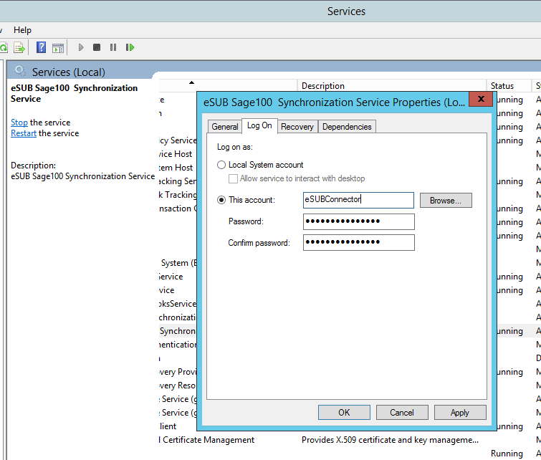
- On Sage Database machine, add the same Windows User (with the same password) as the Windows user (in step 3) of the Connector Machine. If using an Active Directory account, you may skip this step.
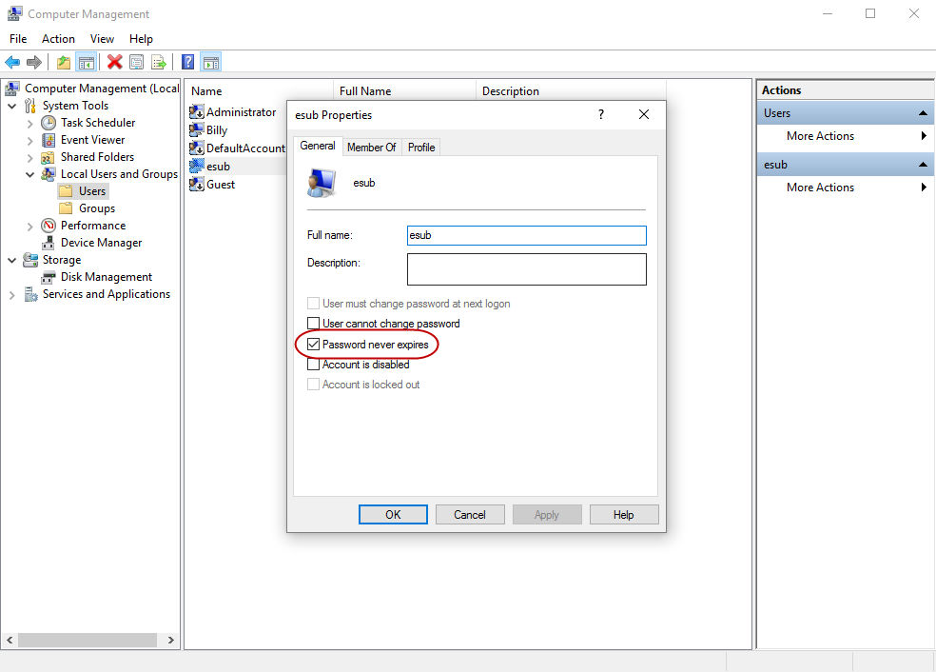

- On the Sage Database Machine, share the MB7 folder (Sage 100 data folder) and provide Full Control to the Windows user account created in Step3.
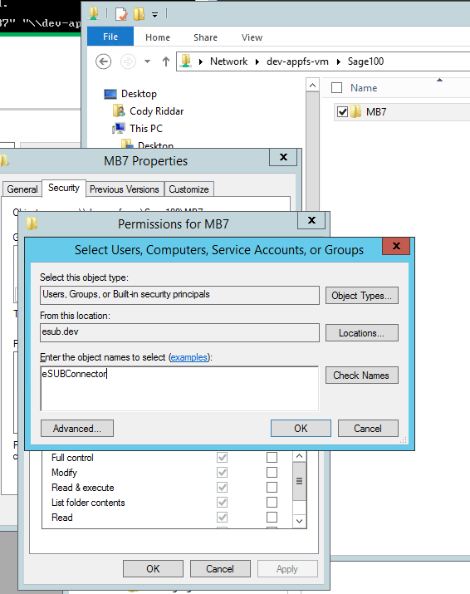

- Go to the Connector Machine, Run Command as Administrator and then run below command to create a remote folder on the C:\ drive for the Sage 100 MB7 data folder. (IMPORTANT: Simply mapping a network drive with Windows Explorer will not work. Windows Services cannot use account-specific mapped drives. Use one of these command prompts):
mklink /D C:\MB7 \\{Sage Machine IP}\MB7
Example: mklink /D C:\MB7 \\192.168.4.102\MB7

- Then run the eSUB Sage 100 Connector, enter the drive we created the remote folder in Step 6 (c: here), enter the correct Company Name, Username and Password of the Sage 100 from the Sage Machine, and then it will connect.
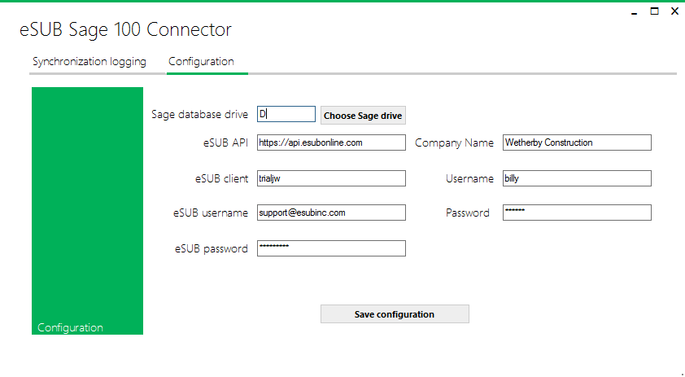
Noteworthy: The connector does support Paths, so if the customer chooses to map the remote folder to something like C:\Sage100\MB7, then the Connector “Sage Database Drive” can be set to C:\Sage100. Do NOT use the Choose Sage Drive button for this. Type it in. Save. Then toggle the tabs to make sure it stuck. It may take a couple tries.
